Daphnia turning exploration

I was looking at the daphnia movement you were describing today and was wondering if a rolling average would be a good way to capture the macro turning patterns in the daphnia. It sounded like the jittery motion was complicating the process of calculating the handedness of the daphnia.   
  
  
Dr. Kogan was describing a method of calculating the angle between vectors. I employed this method by calculating the cross product between <n-1, n > and <n, n+1> . I then just summed up how many of each type (left/right/straight) turns there were. Here are the plot and results for the regular data:

NOTE: attached to the email are higher res pictures where you can better see the smoothing effect.

NO SMOOTHING

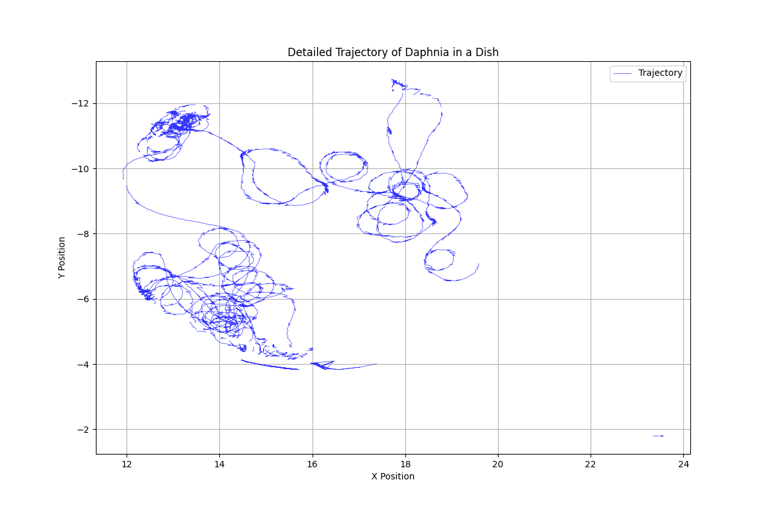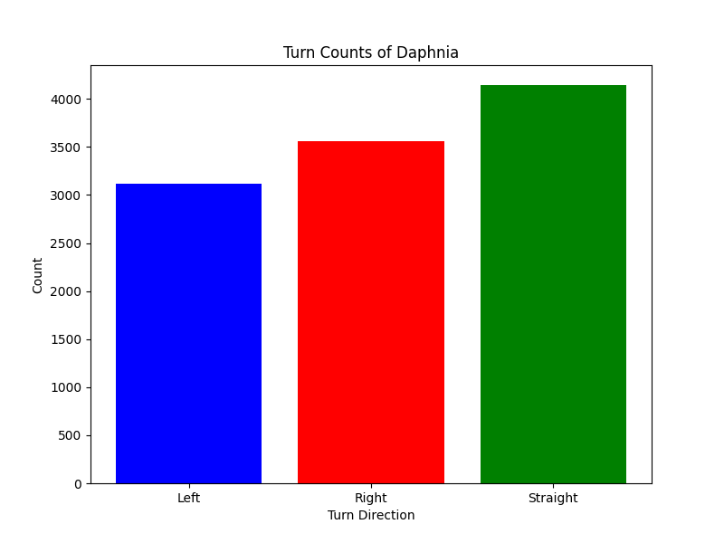

Here are the plots with a rolling average window of 10 frames:

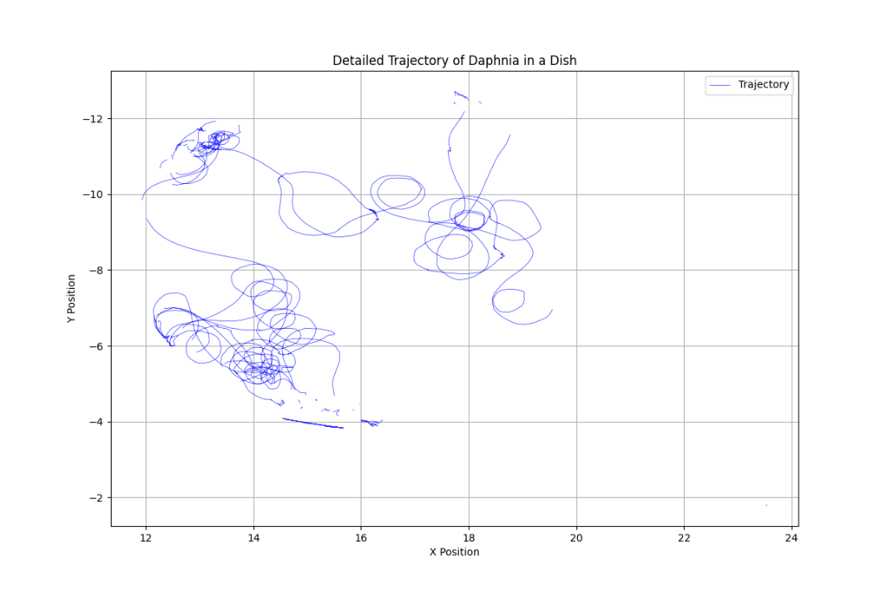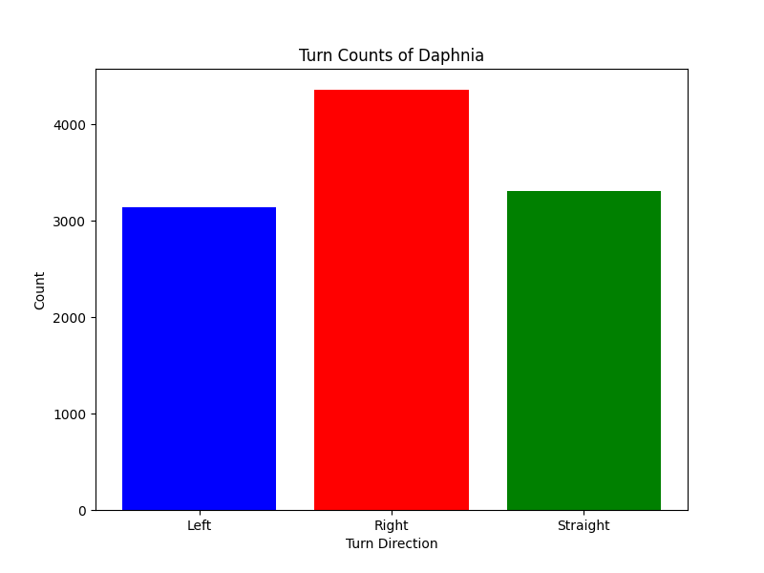

The smoothing seems to accentuate the handedness trend in the unsmoothed data. I know data manipulation is a serious concern for the project, but I thought the results were interesting enough to share.